MACHINE LEARNING FRAMEWORK FOR EARLY WARNING OF DISSOLVED-OXYGEN DETERIORATION IN RIVERS
A PROJECT REPORT
Submitted by

JACKROSHAN J (RA2411003020031)
YAGNESH C (RA2411003020036)
KIRITHIKJI A (RA2411003020044)

Under the guidance of
Dr. Sahaya Sakila V
(Assistant Professor, Department of Computer Science and Engineering)

in partial fulfilment for the award of the degree of
BACHELOR OF TECHNOLOGY
in
COMPUTER SCIENCE AND ENGINEERING
of
FACULTY OF ENGINEERING AND TECHNOLOGY


SRM INSTITUTE OF SCIENCE AND TECHNOLOGY RAMAPURAM, CHENNAI -600089
OCT 2026
SRM INSTITUTE OF SCIENCE AND TECHNOLOGY
(Deemed to be University U/S 3 of UGC Act, 1956)

BONAFIDE CERTIFICATE

Certified that this project report titled “Multimodal Machine Learning Framework for Early Warning of Dissolved-Oxygen Deterioration in Rivers” is the bonafide work of JACKROSHAN J [REG NO: RA2411003020031], YAGNESH C [REG NO: RA2411003020036] and KIRITHIKJI A [REG NO: RA2411003020044] who carried out the project work under my supervision. Certified further, that to the best of my knowledge the work reported herein does not form any other project report or dissertation on the basis of which s degree or award was conferred on an occasion on this or any other candidate.

SIGNATURE  Dr. Sahaya Sakila V M.E., Ph.D.,  Assistant Professor  Computer Science and Engineering,  SRM Institute of Science and Technology,  Ramapuram, Chennai. | SIGNATURE  Dr.K.Raja M.E., Ph.D.,  Professor and Head  Computer Science and Engineering,  SRM Institute of Science and Technology,  Ramapuram, Chennai.

Submitted for the project viva-voce held on ___________ at SRM Institute of Science and Technology, Ramapuram, Chennai -600089.

INTERNAL EXAMINER 1 INTERNAL EXAMINER 2
SRM INSTITUTE OF SCIENCE AND TECHNOLOGY RAMAPURAM, CHENNAI - 89

DECLARATION

We hereby declare that the entire work contained in this project report titled “MACHINE LEARNING FRAMEWORK FOR EARLY WARNING OF DISSOLVED-OXYGEN DETERIORATION IN RIVERS” has been carried out by JACKROSHAN J [REG NO: RA2411003020031], YAGNESH C [REG NO: RA2411003020036] and KIRITHIKJI A [REG NO: RA2411003020044] at SRM Institute of Science and Technology, Ramapuram Campus, Chennai- 600089, under the guidance of Dr. SAHAYA SAKILA V Assistant Professor, Department of Computer Science and Engineering.

Place: Chennai
Date:

JACKROSHAN J

YAGNESH C

KIRITHIKJI A

ABSTRACT

Dissolved oxygen deterioration is a major environmental concern that affects aquatic ecosystems, biodiversity, and overall river water quality. Early detection of declining dissolved oxygen levels is essential for preventing ecological damage and supporting timely water management decisions. This project, titled “Machine Learning Framework for Early Warning of Dissolved-Oxygen Deterioration in Rivers,” proposes a machine learning-based framework for predicting dissolved oxygen deterioration events in rivers. The system integrates water quality measurements from the USGS National Water Information System, meteorological data from ERA5, and atmospheric composition data from CAMS. The dataset covers 15 river monitoring stations and contains 337,248 hourly records collected between 2023 and 2025. The framework incorporates data preprocessing, causal feature engineering, event-onset classification, and ensemble learning to identify potential deterioration events. Dissolved oxygen levels below 5.0 mg/L are defined as deterioration events, provided that the preceding 24 hours satisfy the healthy oxygen condition. The prediction process evaluates four forecast horizons of 6, 12, 24, and 48 hours using LightGBM models and a logistic regression-based stacked ensemble. Early fusion and late fusion architectures are compared to determine the effectiveness of combining different environmental data sources. Model performance is evaluated using a strict temporal validation strategy, with data from 2023 used for training, 2024 for tuning, and an independent 2025 dataset for final testing. The results indicate that additional weather and atmospheric data do not provide a statistically significant improvement over water quality sensor data alone, while the machine learning framework extends warning lead time by approximately 4 to 9 hours at the 24-hour and 48-hour forecast horizons compared with conventional threshold-based alerts. SHAP-based explainability is incorporated to identify important environmental factors influencing deterioration risk, while an interactive Streamlit dashboard supports risk visualization and early warning. The proposed framework provides a foundation for proactive river water quality management by enabling earlier detection of dissolved oxygen deterioration and supporting timely environmental intervention.
.

TABLE OF CONTENTS

Chapter No. | Title | Page No.
 | Abstract  List of Figures  List of Tables  List of Abbreviations | iv  viii  ix  x
1 | Introduction | 1
2 | Literature Review | 3
3 | Proposed Methodology  - Overview of Proposed Methodology  - System Architecture  - Data Flow Diagram  - Dataset Collection and Preprocessing  3.4.1 Dataset Collection  3.4.2 Dataset Inspection  3.4.3 Data Cleaning and Missing-Value Handling  3.4.4 Temporal Alignment and Data Integration  3.4.5 Training, Tuning, and Testing Split  3.4.6 Deterioration Event Definition  3.4.7 Class Imbalance Analysis  - Feature Engineering  3.5.1 Water Quality Features  3.5.2 Meteorological Features  3.5.3 Atmospheric Composition Features  3.5.4 Temporal and Historical Features  3.5.5 Features Integration  - Event-Onset Classification Framework  3.6.1 Six-Hour Forecasting  3.6.2 Twelve-Hour Forecasting  3.6.3 Twenty-Four-Hour Forecasting  3.6.4 Forty-Eight-Hour Forecasting  3.6.5 Integration of Forecast Horizons  - Modal Development and Ensemble Learning  3.7.1 LightGBM Classifier  3.7.2 Early Fusion Approach  3.7.3 Late Fusion Using Stacking  3.7.4 Modality Ablation Analysis  - Performance Evaluation  3.8.1 Accuracy  3.8.2 Precision  3.8.3 Recall  3.8.4 F1-Score  3.8.5 Precision-Recall Analysis  3.8.6 Lead-Time Evaluation  3.8.7 Temporal Validation  3.8.8 Comparison of Fusion Strategies  - Explainable Artificial Intelligence Using SHAP  - Early Warning Dashboard | 6  6  7  8  9  9  9  9  10  10  11  11  12  12  12  12  13  13  13  13  13  14  14  15  15  15  15  16  16  16  17  17  18  18  19  19  20  20  20  21
4 | Results and Discussion  - Evaluation Metrics Achieved  - Efficiency of Proposed System  - Comparison Between Existing and Proposed System  - Results | 22  22  23  24  25
5 | Conclusion | 28
6 | Future Enhancement | 30
7 | Source Code | 32
 | References | 59

LIST OF FIGURES

FIG.NO | FIGURE NAME | PAGE NO
3.1  3.2  3.3  3.4  3.5  3.6  4.1  4.2  4.3  4.4  4.5 | SYSTEM ARCHITECTURE DIAGRAM  DATA FLOW DIAGRAM  ACCURACY COMPARISON GRAPH  PRECISION COMPARISON GRAPH  RECALL COMPARISON GRAPH  F1-SCORE COMPARISON GRAPH  OVERALL MODEL PERFORMANCE COMPARISION  CONFUSION MATRICES  ROC CURVE ANALYSIS  CROSS VALIDATION PERFORMANCE  MODEL ERROR CORRELATION | 7  8  17  18  18  19  25  26  26  27  27

LIST OF TABLES

TAB.NO | TABLE NAME | PAGE NO
4.1  4.2 | COMPLETE MODAL PERFORMANCE EVALUATION  PERFORMANCE OF THE PROPOSED STACKING ENSEMBLE ACROSS FORECAST HORIZONS | 22  23

LIST OF ABBREVIATIONS

Abbreviation | Full Form
DO | Dissolved Oxygen
ML | Machine Learning
AI | Artificial Intelligence
USGS | United States Geological Survey
NWIS | National Water Information System
ERA5 | ECMWF Reanalysis Version 5
CAMS | Copernicus Atmosphere Monitoring Service
LightGBM | Light Gradient Boosting Machine
SHAP | SHapley Additive exPlanations
BOD | Biochemical Oxygen Demand
RMSE | Root Mean Square Error
MAE | Mean Absolute Error
XAI | Explainable Artificial Intelligence
UTC | Coordinated Universal Time
PM2.5 | Fine Particulate Matter
PM10 | Coarse Particulate Matter
NO₂ | Nitrogen Dioxide
SO₂ | Sulfur Dioxide
CO | Carbon Monoxide
mg/L | Milligrams per Liter

Chapter 1

INTRODUCTION
Dissolved oxygen (DO) is an important indicator of river water quality and plays a vital role in maintaining aquatic ecosystems. It refers to the amount of oxygen dissolved in water, which is essential for the survival of fish and other aquatic organisms. A significant decrease in dissolved oxygen levels can lead to poor water quality, damage to aquatic habitats, and ecological imbalance. Therefore, monitoring dissolved oxygen and identifying its deterioration at an early stage are essential for effective river management.

Traditional water quality monitoring methods generally identify oxygen deterioration when dissolved oxygen levels fall below a predefined threshold. Although this approach helps detect critical conditions, it may provide insufficient time for authorities to take preventive measures. Changes in water temperature, river discharge, pollution levels, and environmental conditions can influence dissolved oxygen concentrations, making early prediction a challenging task.

Machine learning provides an effective approach to analyzing environmental data and identifying patterns associated with declining dissolved oxygen levels. By learning from historical water quality measurements and related environmental variables, machine learning models can estimate the risk of future deterioration. This enables the development of early warning systems that can support proactive environmental monitoring and timely decision-making.

The proposed project, “Machine Learning Framework for Early Warning of Dissolved-Oxygen Deterioration in Rivers,” focuses on developing a predictive framework that identifies potential dissolved oxygen deterioration events before they occur. The system integrates hourly water quality observations from the United States Geological Survey (USGS), meteorological data from ERA5, and atmospheric composition data from CAMS. The dataset covers 15 river monitoring stations and contains approximately 337,248 hourly records collected between 2023 and 2025.

The framework uses machine learning techniques, including LightGBM and a logistic regression-based stacking ensemble, to predict deterioration events across multiple forecast horizons of 6, 12, 24, and 48 hours. It incorporates data preprocessing, feature engineering, temporal validation, and explainable artificial intelligence techniques to improve the reliability and interpretability of predictions. The system also compares different data integration strategies to determine whether combining water quality, weather, and atmospheric information improves early warning performance.

The proposed system aims to provide earlier warnings than conventional threshold-based monitoring by predicting potential deterioration before dissolved oxygen reaches critical levels. An interactive Streamlit dashboard presents risk information and model explanations to support the interpretation of predictions. Overall, this project provides a machine learning-based approach to proactive river water quality monitoring, with the potential to support timely environmental interventions and help protect aquatic ecosystems.

Chapter 2

LITERATURE REVIEW
Moon et al. [1] presented “Urban River Dissolved Oxygen Prediction Model Using Machine Learning” in 2022. The study investigated machine learning approaches for predicting dissolved oxygen levels in urban rivers. The research focused on identifying patterns in water quality data to improve the prediction of dissolved oxygen concentrations. The study demonstrates the usefulness of machine learning techniques for river water quality forecasting and provides a foundation for developing predictive models that can support environmental monitoring and water resource management.
Rocha et al. [2] presented “New Graph-Based and Transformer Deep Learning Models for River Dissolved Oxygen Forecasting” in 2023. The researchers explored graph-based and transformer-based deep learning techniques for forecasting dissolved oxygen levels in rivers. Their work investigated the use of advanced models to capture relationships in environmental time-series data. The study highlights the potential of deep learning methods for river oxygen forecasting and provides useful background for developing more advanced prediction frameworks. However, forecasting numerical dissolved oxygen values differs from directly predicting the onset of deterioration events.
Pant et al. [3] proposed “Multi-Step Forecasting of Dissolved Oxygen in River Ganga Based on CEEMDAN-AdaBoost-BiLSTM-LSTM Model” in 2024. The study combined signal decomposition, boosting, and recurrent neural network techniques to predict dissolved oxygen levels in the River Ganga. The approach aimed to capture complex temporal patterns and improve multi-step forecasting performance. The research demonstrates the potential of hybrid machine learning and deep learning models for river water quality prediction. Its findings are relevant to the proposed project, which focuses on identifying future dissolved oxygen deterioration and providing advance warnings.
Granata et al. [4] investigated “Dissolved Oxygen Forecasting in the Mississippi River: Advanced Ensemble Machine Learning Models” in 2024. The researchers examined ensemble machine learning techniques for forecasting dissolved oxygen concentrations in the Mississippi River. Their work demonstrated the application of combined predictive models to environmental time-series data. The study provides a useful foundation for exploring ensemble learning in river water quality monitoring. The proposed framework extends this research direction by emphasizing deterioration-event detection, multiple warning horizons, and the practical lead time available before an event occurs.
Cerqueira et al. [5] presented research on forecasting ocean hypoxia in salmonid fish farms in 2024. The study investigated LightGBM-based forecasting for identifying low-oxygen conditions over different prediction horizons. It is relevant because it focuses on anticipating oxygen-related environmental events rather than only estimating continuous oxygen values. The research provides a useful reference for selecting gradient-boosting methods and evaluating advance warning capabilities. The proposed project applies a related predictive approach to river monitoring and compares machine learning warnings with conventional threshold-based alerts.
Simonetti et al. [6] investigated the use of hydrodynamic modelling and Random Forest classifiers for predicting hypoxia in coastal lagoons in 2024. The study combined environmental modelling and machine learning to identify conditions associated with oxygen depletion. Its findings illustrate how classification algorithms can support the prediction of low-oxygen events in aquatic environments. Although coastal lagoons differ from river systems, the research is relevant to the proposed framework because both address the early identification of potentially harmful oxygen conditions.
Zhao and Chen [7] presented “Prediction of River Dissolved Oxygen (DO) Based on Multi-Source Data and Various Machine Learning Coupling Models” in 2025. The researchers investigated different machine learning models and combinations of environmental data sources for predicting river dissolved oxygen levels. The study highlights the importance of integrating relevant environmental information and comparing predictive approaches. This research is closely related to the proposed project, which combines water quality observations with meteorological and atmospheric data to examine whether multiple data sources improve early warning performance.
Merabet et al. [8] investigated the prediction of water quality variables using gradient-boosting methods and compared global and local explainability using SHapley Additive exPlanations (SHAP) in 2025. The study demonstrated the importance of understanding how machine learning models produce their predictions. Explainability techniques can help identify the environmental variables that contribute to model outputs and improve the interpretability of water quality predictions. The proposed framework incorporates SHAP-based analysis to investigate the factors associated with dissolved oxygen deterioration and provide explanations for predicted risks.
Choudhary et al. [9] proposed “Predicting Water Quality Index Using Stacked Ensemble Regression and SHAP Based Explainable Artificial Intelligence” in 2025. The study combined stacked ensemble learning with SHAP-based explainability to improve water quality prediction and interpretation. The research demonstrates the usefulness of combining multiple predictive models and examining the contribution of individual features. It provides a methodological reference for the proposed project, which uses a logistic regression-based stacking architecture to combine model outputs and employs SHAP to interpret deterioration predictions.

Chapter 3
PROJECT METHODOLOGY
3.1 Overview of the Proposed Methodology
The proposed methodology presents a systematic approach for developing a machine learning framework for the early warning of dissolved-oxygen deterioration in rivers. The primary objective is to predict potential low-oxygen events before they occur by integrating water quality measurements, meteorological information, atmospheric data, and machine learning techniques. The framework includes data collection, preprocessing, feature engineering, event-onset classification, ensemble learning, model evaluation, and explainability.

The project integrates hourly water quality observations from the United States Geological Survey (USGS), meteorological data from ERA5, and atmospheric composition data from CAMS. The dataset covers 15 river monitoring stations and contains approximately 337,248 hourly records spanning 2023 to 2025.

The methodology defines a deterioration event as dissolved oxygen falling below 5.0 mg/L after a preceding 24-hour period in which dissolved oxygen remained at or above 5.0 mg/L. Machine learning models are developed to predict these events across four forecast horizons: 6, 12, 24, and 48 hours. LightGBM classifiers and a logistic regression-based stacking ensemble are evaluated to determine their effectiveness in identifying future deterioration.

The framework also compares early fusion and late fusion strategies to investigate whether combining multiple environmental data sources improves prediction performance. Model interpretability is addressed using SHAP, while a strict temporal validation strategy evaluates generalization to an independent test year. The results are used to assess warning lead time and compare the proposed framework with conventional threshold-based monitoring.

3.2 System Architecture
The system architecture describes the organization and interaction of the major components of the proposed dissolved-oxygen deterioration warning framework. It illustrates how environmental data are collected, processed, transformed into predictive features, and supplied to machine learning models to estimate the risk of future deterioration events.

The system begins by integrating three data sources: in-situ water quality observations from USGS, meteorological information from ERA5, and atmospheric composition measurements from CAMS. The datasets are harmonized to an hourly UTC time scale, followed by data cleaning, missing-value handling, feature preparation, and the generation of predictive variables.

The processed data are supplied to the classification models for four forecast horizons. Early fusion combines different data sources at the feature level, while late fusion combines model predictions using a logistic regression-based stacking approach. The resulting predictions are evaluated using event-detection metrics, lead-time analysis, and SHAP-based explanations.

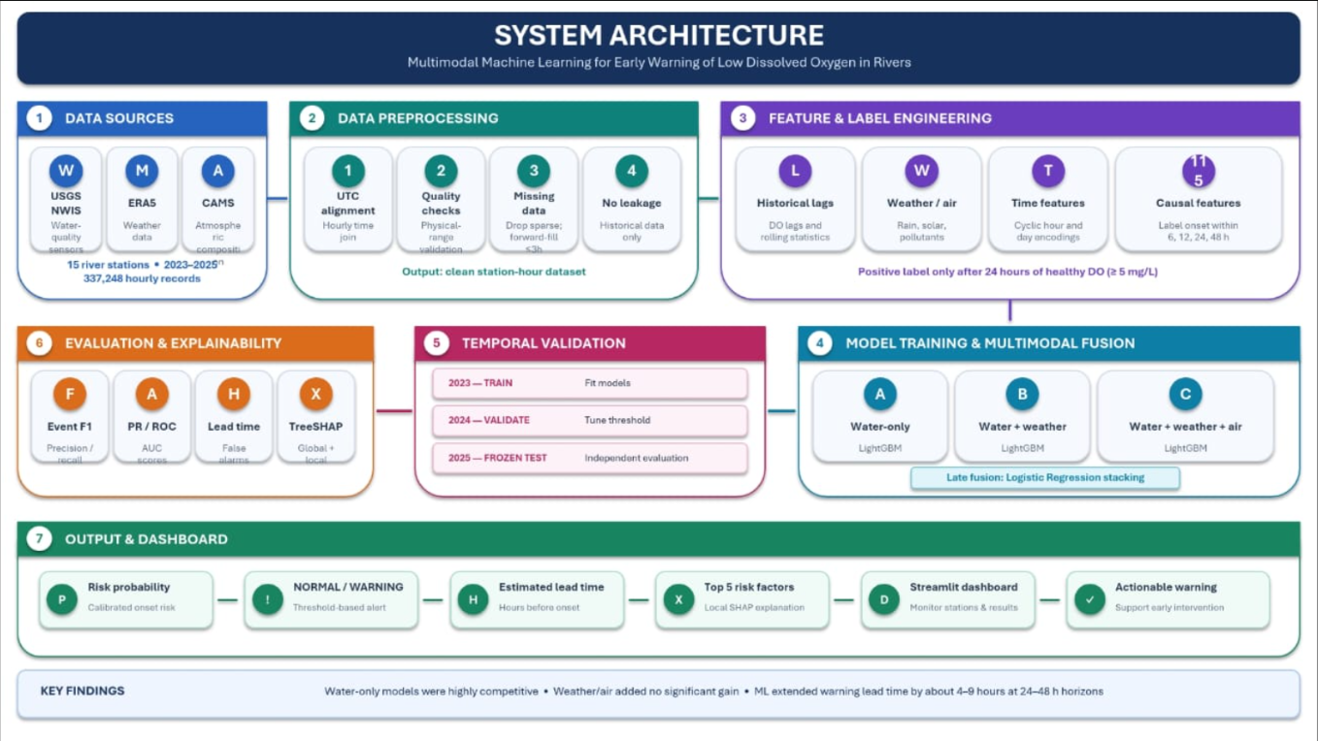
Figure 3.1: System Architecture Diagram
3.3 Data Flow Diagram
A The data flow diagram represents the sequence of operations performed by the proposed framework, from environmental data collection to the generation of early warning predictions.

The process begins with the collection of hourly river water quality, meteorological, and atmospheric data. These datasets undergo preprocessing and temporal alignment before predictive features are generated. The processed information is then used to train and evaluate LightGBM models and the stacking ensemble across the selected forecast horizons.

The trained models estimate the probability of future dissolved-oxygen deterioration. These predictions are compared with actual deterioration events to evaluate classification performance and warning lead time. SHAP analysis is used to interpret model outputs, and the results are presented through an interactive Streamlit dashboard.

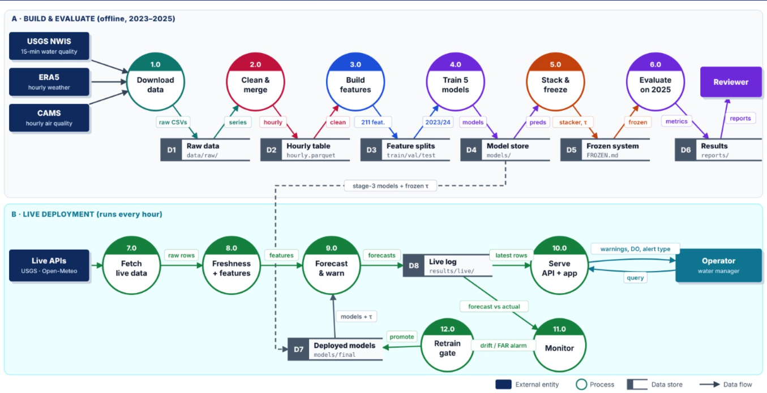
Figure 3.2: Data Flow Diagram of the Proposed Thyroid Disorder Classification Framework

3.4 Dataset Collection and Preprocessing
Dataset collection and preprocessing form the foundation of the proposed machine learning framework. Environmental data may contain missing observations, inconsistent timestamps, different measurement frequencies, and variations in data quality. Proper preprocessing is therefore necessary to prepare a consistent dataset for training and evaluation.

3.4.1 Dataset Collection
The project uses environmental observations from 15 river monitoring stations across the United States. Water quality data are obtained from the USGS National Water Information System (NWIS), meteorological variables from ERA5, and atmospheric composition data from CAMS.

The water quality variables include dissolved oxygen, water temperature, specific conductance, pH, turbidity, and river discharge. Meteorological variables include air temperature, dew point, solar radiation, precipitation, surface pressure, and wind speed. Atmospheric variables include particulate matter, nitrogen dioxide, sulfur dioxide, carbon monoxide, and total aerosol optical depth.

The integrated dataset contains approximately 337,248 hourly records spanning 2023 to 2025. These observations provide the basis for identifying environmental patterns associated with dissolved-oxygen deterioration.

3.4.2 Dataset Inspection
The collected datasets are examined to understand their structure, data types, timestamp formats, missing values, and variable distributions. The inspection process also identifies duplicate observations, inconsistent measurements, and differences in temporal coverage across data sources.

This stage helps determine whether the datasets can be combined reliably and identifies variables that require additional preprocessing. Particular attention is given to dissolved oxygen measurements because they are used to define deterioration events and establish the prediction targets.

3.4.3 Data Cleaning and Missing-Value Handling
Missing values and invalid observations can affect the reliability of machine learning predictions. The preprocessing stage examines missing environmental measurements and applies suitable handling procedures according to the characteristics of each variable.

Timestamp inconsistencies and duplicate records are addressed where necessary. The treatment of missing observations is performed carefully to avoid introducing artificial patterns into the environmental time series. Preprocessing operations are fitted or determined using the appropriate training data wherever applicable, reducing the risk of information leakage into the evaluation data.

3.4.4 Temporal Alignment and Data Integration
The three data sources may differ in their original timestamps, temporal resolution, and data availability. To create a consistent input dataset, the observations are aligned to an hourly UTC time scale.

Water quality measurements, weather variables, and atmospheric information are combined using their corresponding timestamps and monitoring locations. The resulting integrated dataset provides a common temporal structure for feature generation and model training.

The integration process also considers data availability at prediction time. Only information that would have been available when a warning was generated should be used as a predictive input.

3.4.5 Training, Tuning, and Testing Split
The project follows a chronological data-splitting strategy to evaluate the framework under realistic forecasting conditions. The data from 2023 are used for training, 2024 for tuning, and 2025 as an independent hold-out test period.

This approach preserves the temporal order of observations and helps evaluate how well the model generalizes to a later period. The model parameters and decision settings are selected without using the final test-year results for tuning. This separation is important because random splitting of time-series data can allow information from later observations to influence training and produce overly optimistic performance estimates.

3.4.6 Deterioration Event Definition
A deterioration event is defined using a dissolved oxygen threshold of 5.0 mg/L. An event begins when dissolved oxygen falls below this threshold after a preceding 24-hour period during which the measured level remained at or above 5.0 mg/L.

This definition distinguishes new deterioration events from periods in which low dissolved oxygen conditions are already continuing. The event-onset formulation allows the framework to predict the beginning of a potentially harmful condition instead of merely identifying an already-existing low-oxygen state.

3.4.7 Class Imbalance Analysis
Dissolved-oxygen deterioration events occur less frequently than normal environmental conditions. Consequently, the dataset contains substantially more non-event observations than event observations.

This class imbalance can cause a model to favor the majority class and overlook important deterioration events. The distribution of positive and negative examples is examined for each prediction horizon. Evaluation emphasizes metrics that measure event detection, including precision, recall, F1-score, and precision-recall performance where applicable, rather than relying exclusively on overall accuracy.

3.5 Feature Engineering
Feature engineering involves transforming the collected environmental observations into meaningful predictive variables. The project uses historical water quality measurements and related environmental information to represent temporal changes, environmental conditions, and patterns associated with dissolved-oxygen deterioration.

3.5.1 Water Quality Features
Water quality measurements form the primary input to the prediction framework. Variables such as dissolved oxygen, water temperature, specific conductance, pH, turbidity, and discharge provide information about the physical and chemical conditions of rivers.

These variables are used to identify patterns that may precede deterioration events. Historical dissolved oxygen values are particularly important because they describe the recent oxygen condition and help represent changes over time.

3.5.2 Meteorological Features
Meteorological features are obtained from ERA5 and include air temperature, dew point, solar radiation, precipitation, surface pressure, and wind speed.

These variables represent atmospheric conditions that may influence river temperature, runoff, and oxygen dynamics. Their inclusion allows the framework to investigate whether weather-related information improves the prediction of future deterioration events.

3.5.3 Atmospheric Composition Features
Atmospheric composition data from CAMS include particulate matter concentrations, nitrogen dioxide, sulfur dioxide, carbon monoxide, and total aerosol optical depth.

These features are incorporated to investigate whether atmospheric information provides additional predictive value when combined with water quality and meteorological observations. Their contribution is assessed experimentally rather than assumed to improve the model.
3.5.4 Temporal and Historical Features
Temporal features represent changes in environmental conditions over time. The framework incorporates causally valid historical information to identify patterns associated with deterioration.

Relevant temporal information includes recent dissolved oxygen conditions, historical minimum values, seasonal patterns, and daily variations. These features help represent changes in oxygen concentration and recurring environmental patterns.

Feature generation must preserve the forecasting timeline. Variables calculated for a prediction must use only observations available at or before the corresponding prediction time.

3.5.5 Feature Integration
The generated features are combined into the final input representation used by the classification models. Different combinations of water quality, meteorological, and atmospheric variables are prepared for the modality comparison experiments.

This stage also supports the comparison of early fusion and late fusion strategies. The resulting feature sets are evaluated to determine whether additional environmental information improves deterioration-event prediction.

3.6 Event-Onset Classification Framework
The event-onset classification framework is the central component of the proposed system. Instead of predicting only the numerical dissolved oxygen concentration, the framework estimates whether a deterioration event is expected to occur within a specified future period.

3.6.1 Six-Hour Forecasting
The six-hour model predicts whether a new dissolved-oxygen deterioration event will occur within the next six hours. This short forecast horizon is intended to identify events approaching in the near future.
The model uses available historical environmental features to estimate deterioration risk. Its predictions are evaluated against the corresponding event labels to determine whether the system can identify imminent deterioration.

3.6.2 Twelve-Hour Forecasting
The twelve-hour model predicts deterioration events within a twelve-hour forecast window. This horizon provides additional time for monitoring teams to assess potential risks and prepare for possible environmental intervention.

The model is trained using the appropriate twelve-hour event labels and is evaluated separately to measure its ability to anticipate deterioration at this timescale.

3.6.3 Twenty-Four-Hour Forecasting
The twenty-four-hour model estimates the probability of a deterioration event occurring within the next 24 hours. This horizon is particularly useful for evaluating whether the framework can provide operationally meaningful advance warning.

Its performance is examined using event-classification metrics and warning lead-time analysis. The results are also compared with those produced by conventional threshold-based monitoring.

3.6.4 Forty-Eight-Hour Forecasting
The forty-eight-hour model aims to identify deterioration events up to two days in advance. This longer forecast horizon may provide additional time for planning and coordinating river management activities.

Longer-term predictions can be more difficult because environmental conditions may change substantially over time. The model is therefore evaluated separately to determine the reliability of its predictions at the extended horizon.

3.6.5 Integration of Forecast Horizons
The four prediction horizons provide different levels of warning time. Their results are compared to assess the relationship between prediction distance and event-detection performance.

The framework evaluates whether each horizon provides useful warning information and identifies the limitations associated with longer forecast periods.

3.7 Model Development and Ensemble Learning
Model development involves training, tuning, and evaluating machine learning classifiers for dissolved-oxygen deterioration prediction. The proposed framework compares LightGBM-based classification with a logistic regression-based stacking architecture.

3.7.1 LightGBM Classifier
LightGBM is a gradient-boosting algorithm designed for efficient learning from structured datasets. It builds a sequence of decision trees in which each new tree attempts to improve upon the errors made by previous trees.

In this project, LightGBM is used to classify potential deterioration events using environmental features. Its ability to represent nonlinear relationships makes it suitable for investigating complex patterns in water quality and environmental time-series data.

3.7.2 Early Fusion Approach
Early fusion combines features from different data sources into a unified input representation before model training. In the proposed framework, water quality, meteorological, and atmospheric variables can be combined into a single feature matrix.

The resulting dataset is supplied to the LightGBM classifier, which learns relationships across the available environmental variables. This approach allows the model to consider information from multiple modalities simultaneously
3.7.3 Late Fusion Using Stacking
Late fusion combines the outputs of separately trained predictive models rather than combining all input features at the beginning. In the proposed framework, the predictions from component models are used as inputs to a logistic regression meta-learner.

The meta-learner learns how to combine the component predictions to generate the final deterioration-risk estimate. This approach allows the framework to examine whether decision-level integration provides better performance than direct feature concatenation.

The stacking process must use suitable training predictions, such as out-of-fold predictions, to reduce the risk of overfitting the meta-learner.

3.7.4 Modality Ablation Analysis
Modality ablation evaluates the contribution of different environmental data sources by comparing models trained with different combinations of input variables.

The experiments compare water quality-only inputs with combinations that additionally include ERA5 weather data and CAMS atmospheric information. The same evaluation framework is used to determine whether the additional modalities provide measurable predictive improvements.
The results of this analysis help identify which data sources contribute useful information and whether a simpler model based primarily on water quality measurements is sufficient.

3.8 Performance Evaluation
Performance evaluation measures the ability of the proposed framework to identify future dissolved-oxygen deterioration events. Multiple metrics are used because the dataset contains a substantial imbalance between deterioration events and non-event observations.

3.8.1 Accuracy
Accuracy measures the proportion of correct predictions among all evaluated observations.

$$Accuracy=\frac{Number of correct predictions}{Total number of predictions}$$

Here, TP represents true positives, TN represents true negatives, FP represents false positives, and FN represents false negatives. Accuracy provides an overall measure of classification performance but may be misleading when deterioration events are relatively rare.

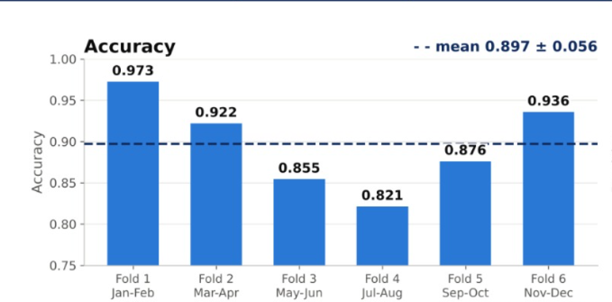
Figure 3.3: Accuracy Comparison Graph

3.8.2 Precision
Precision measures the proportion of predicted deterioration events that correspond to actual events.
$$Precision= \frac{TP}{TP+FP}$$
Higher precision indicates that fewer generated warnings are false alarms. This measure is important when evaluating whether the warning system produces reliable alerts.

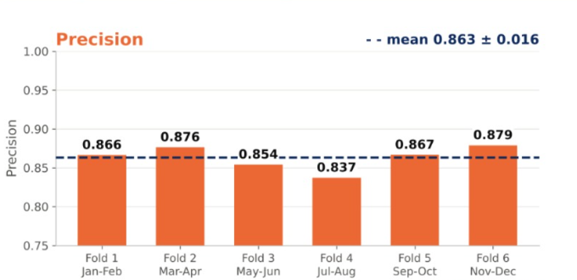
Figure 3.4: Precision Comparison Graph

3.8.3 Recall
Recall measures the proportion of actual deterioration events correctly identified by the model.
$$Recall= \frac{TP}{TP+FN}$$

Higher recall indicates that the model identifies a larger proportion of deterioration events. This metric is particularly important because missed events may reduce the practical value of an early warning system.

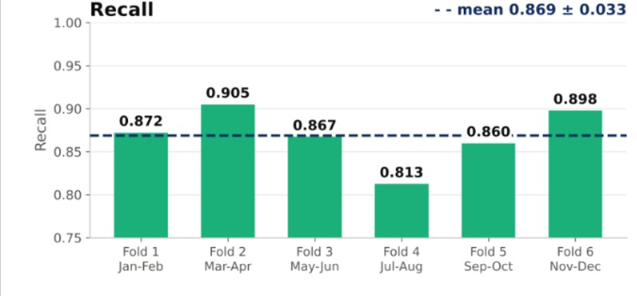
Figure 3.5: Recall Comparison Graph

3.8.4 F1-Score
The F1-score is the harmonic mean of precision and recall.
$$F1=2 X \frac{Precision X Recall}{Precision+Recall}$$

The F1-score provides a combined measure of precision and recall. It is useful when evaluating models trained on imbalanced environmental datasets.

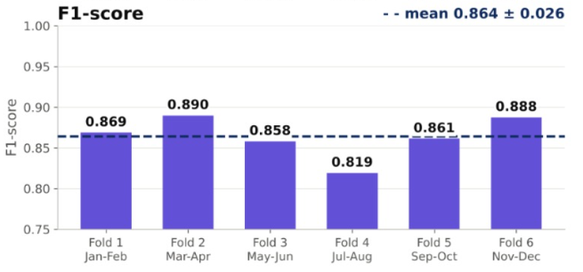
Figure 3.6: F1-Score Comparison Graph

3.8.5 Precision-Recall Analysis
Precision-recall analysis examines the relationship between the proportion of correct warnings and the proportion of actual events detected across different classification thresholds.

This analysis is particularly useful for rare-event prediction because conventional accuracy may remain high even when a model fails to identify a substantial number of deterioration events.

3.8.6 Lead-Time Evaluation
Lead time measures the amount of time between the generation of an early warning and the actual onset of a deterioration event.
$$\text{Lead Time}=t_{\text{onset}}-t_{\text{warning}}$$
A positive lead time indicates that the warning was generated before the event occurred. The framework compares its warning lead time against a conventional threshold-based baseline to assess the practical benefit of predictive monitoring.
3.8.7 Temporal Validation
The project uses chronological training, tuning, and testing periods to evaluate model generalization. Data from 2023 are used for training, 2024 for tuning, and 2025 for independent testing.

This evaluation strategy reduces the risk of temporal information leakage and provides a more realistic assessment of performance on future observations. The final test period is reserved for evaluation after model selection is complete.

3.8.8 Comparison of Fusion Strategies
The early fusion and late fusion approaches are evaluated using consistent data partitions, forecast horizons, and performance measures.

The comparison determines whether combining model predictions through stacking provides advantages over combining all environmental variables directly. It also examines whether the inclusion of weather and atmospheric data improves performance compared with water quality-only models.

3.9 Explainable Artificial Intelligence Using SHAP
Explainable Artificial Intelligence (XAI) is incorporated to improve the interpretability of the proposed framework. Although machine learning models can identify complex patterns in environmental data, understanding the variables responsible for individual predictions is important for evaluating their practical usefulness.

SHAP is used to estimate the contribution of input features to model predictions. Global explanations identify features that have substantial influence across many observations, while local explanations examine the variables contributing to a particular deterioration-risk prediction.

The project uses SHAP-based analysis to investigate the influence of historical dissolved oxygen levels, seasonal patterns, daily fluctuations, and other available environmental variables. These explanations provide additional information about model behavior and help assess whether predictions are associated with meaningful environmental patterns.

3.10 Early Warning Dashboard
The project includes an interactive Streamlit dashboard for presenting model predictions and supporting the interpretation of deterioration risk.

The dashboard provides a user-facing interface for viewing forecast information, risk estimates, and relevant model explanations. It is intended to make the results of the machine learning framework easier to understand than raw model outputs alone.

The dashboard can present prediction horizons, deterioration-risk probabilities, evaluation summaries, and SHAP-based explanations according to the implemented functionality. The interface serves as a demonstration of how predictive results could be communicated to environmental monitoring personnel.

Chapter 4

RESULTS AND DISCUSSION

Evaluation Metrics Achieved
All models were evaluated once on the unseen 2025 test year, covering 30 river monitoring stations and approximately 251,000 hourly forecasts per prediction horizon. Precision, recall, and F1-score were macro-averaged across the three dissolved-oxygen classes: Low (DO < 5 mg/L), Medium (DO from 5 to 7 mg/L), and Good (DO > 7 mg/L). All classifiers used the same predefined warning rule to ensure a consistent evaluation procedure.

Model Type | Model | Accuracy  (%) | Precision  (%) | Recall  (%) | F1-Score  (%)
Baseline | Persistence (no change) | 90.07 | 88.06 | 88.06 | 88.06
Baseline | Logistic Regression | 88.72 | 86.24 | 88.53 | 87.22
Machine Learning | Random Forest | 90.57 | 88.08 | 89.55 | 88.75
Machine Learning | XGBoost | 90.46 | 87.89 | 89.55 | 88.64
Machine Learning | LightGBM | 90.47 | 87.93 | 89.59 | 88.69
Deep Learning | BiLSTM | 89.63 | 87.23 | 88.79 | 87.95
Deep Learning | CNN-LSTM | 89.36 | 86.54 | 88.73 | 87.53
Proposed Ensemble | Stacking Ensemble (RF + XGBoost + LightGBM + BiLSTM + CNN-LSTM) | 90.39 | 87.78 | 89.60 | 88.60
Table 4.1: Complete Model Performance Evaluation (24 h ahead, 2025 test year)

Forecast Horizon | Model | Accuracy  (%) | Precision  (%) | Recall  (%) | F1-Score  (%)
6 h ahead | Stacking Ensemble | 92.08 | 89.74 | 91.42 | 90.52
12 h ahead | Stacking Ensemble | 91.37 | 88.91 | 90.67 | 89.72
24 h ahead | Stacking Ensemble | 90.39 | 87.78 | 89.60 | 88.60
48 h ahead | Stacking Ensemble | 87.57 | 84.74 | 86.69 | 85.62
Table 4.2: Performance of the Proposed Stacking Ensemble across Forecast Horizons (2025 test year)

4.2 Efficiency of the Proposed System
The proposed dissolved-oxygen deterioration prediction framework is designed to improve the early identification of potentially unsafe river-water conditions through machine learning, deep learning, and ensemble techniques. The system analyses historical water-quality measurements and relevant environmental information to identify patterns associated with changes in dissolved-oxygen levels. By generating predictions at multiple forecast horizons, the framework aims to provide advance information about possible deterioration rather than relying exclusively on alerts triggered after a threshold has been crossed.

Data preprocessing and temporal alignment are important components of the proposed system. Water-quality observations and external environmental data may be recorded at different intervals or contain missing values. Preparing these datasets provides consistent inputs for model training and prediction. The framework evaluates different algorithms, including Random Forest, XGBoost, LightGBM, BiLSTM, and CNN-LSTM, to compare their ability to classify dissolved-oxygen conditions.

The stacking ensemble combines predictions from multiple models to generate the final classification. The experimental results show that the ensemble achieved an accuracy of 90.39% and an F1-score of 88.60% at the 24-hour forecast horizon. Although Random Forest achieved slightly higher accuracy and F1-score at this horizon, the ensemble provides an alternative approach that integrates predictions from multiple learning algorithms.

The evaluation across different forecast horizons demonstrates that model performance decreases as the prediction period increases. The ensemble achieved an accuracy of 92.08% at 6 hours ahead and 87.57% at 48 hours ahead. This difference highlights the challenge of making longer-term predictions while also demonstrating the model's ability to classify dissolved-oxygen conditions beyond the shortest forecasting period.

Overall, the proposed system provides a structured framework for analysing river-water-quality data and predicting dissolved-oxygen conditions. Its performance can be further examined through confusion matrices, ROC curves, feature-importance analysis, and comparisons between individual models and the ensemble. These evaluations help identify areas for improvement and support the development of more reliable early-warning systems.

4.3 Comparison Between Existing and Proposed System
Existing approaches to dissolved-oxygen monitoring commonly rely on water-quality sensors, periodic sampling, and threshold-based alerts. In a threshold-based system, an alert is generated when the measured dissolved-oxygen concentration falls below a predefined limit. Although this method is straightforward, it may provide limited advance warning because the alert is triggered after the threshold condition occurs. Conventional machine learning models can also be used to classify or forecast water-quality conditions based on historical measurements.

The proposed system uses a machine learning and deep learning framework to predict dissolved-oxygen conditions at multiple forecast horizons. It evaluates Random Forest, XGBoost, LightGBM, BiLSTM, and CNN-LSTM models and combines their predictions through a stacking ensemble. This approach enables the performance of individual algorithms to be compared with that of the combined model under a consistent evaluation procedure.

The proposed stacking ensemble achieved an accuracy of 90.39% and an F1-score of 88.60% at the 24-hour forecast horizon. Random Forest achieved an accuracy of 90.57% and an F1-score of 88.75% at the same horizon. Therefore, the results do not establish that the ensemble outperforms all individual models. Instead, they demonstrate that the ensemble achieves competitive classification performance while integrating several learning approaches.

The evaluation at different forecast horizons is another important aspect of the proposed framework. The ensemble achieved an accuracy of 92.08% at 6 hours ahead and 87.57% at 48 hours ahead. This demonstrates the variation in predictive performance over different time intervals and helps assess the potential usefulness of the system for advance water-quality monitoring.

Overall, the proposed framework offers a systematic approach to predicting dissolved-oxygen conditions by comparing multiple algorithms and combining their outputs. Further evaluation against threshold-based monitoring and other existing approaches using consistent testing conditions would help establish its practical advantages for river-water-quality management.

  - Results

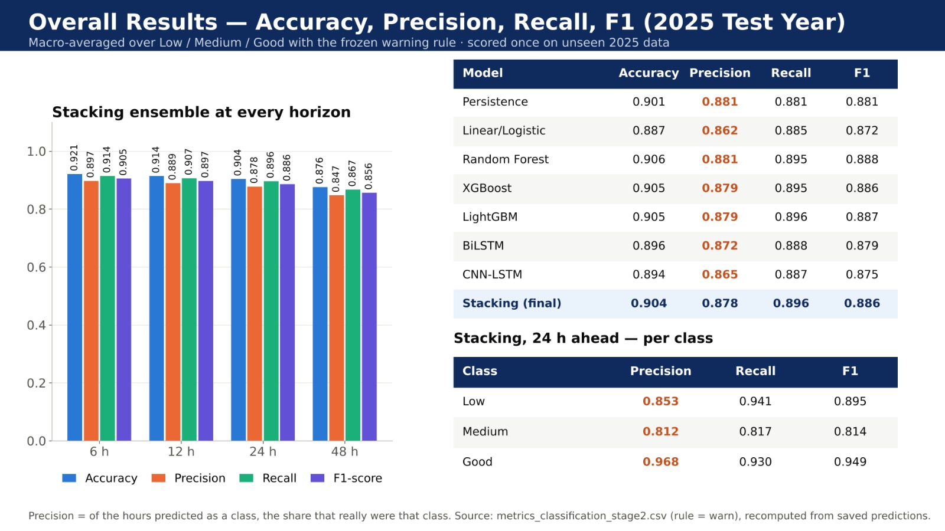
Figure 4.1: Overall Model Performance Comparison
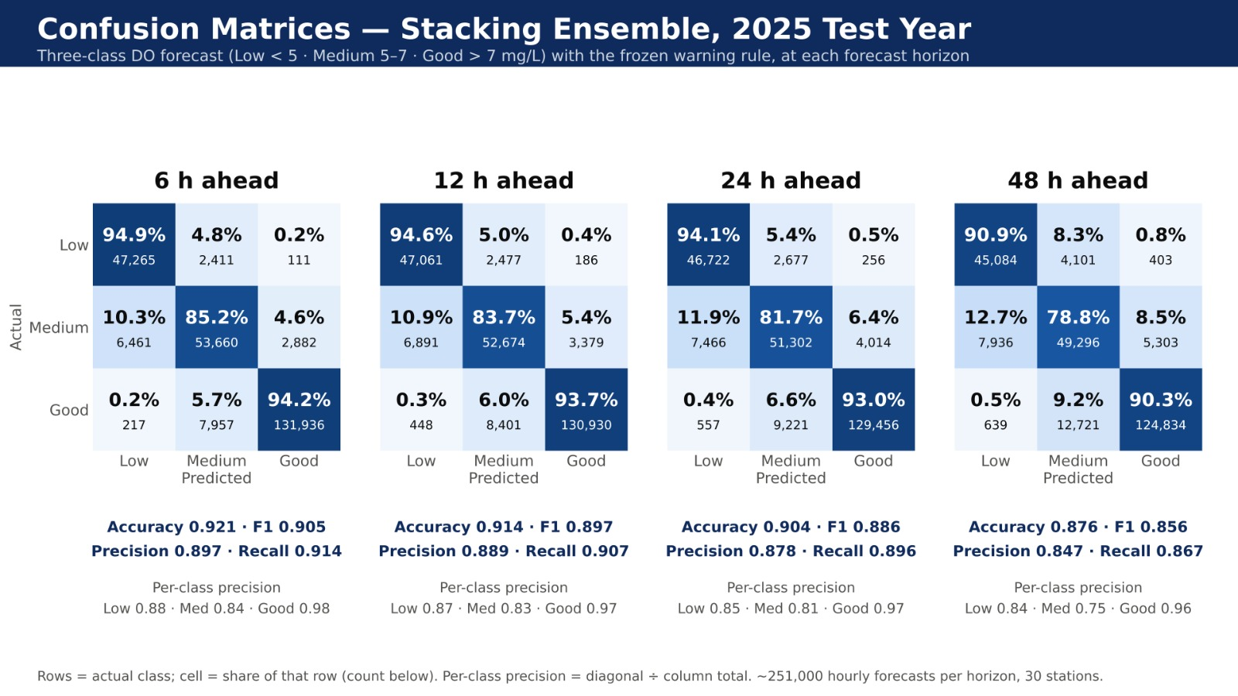
Figure 4.2: Confusion Matrices Across Forecast Horizons.

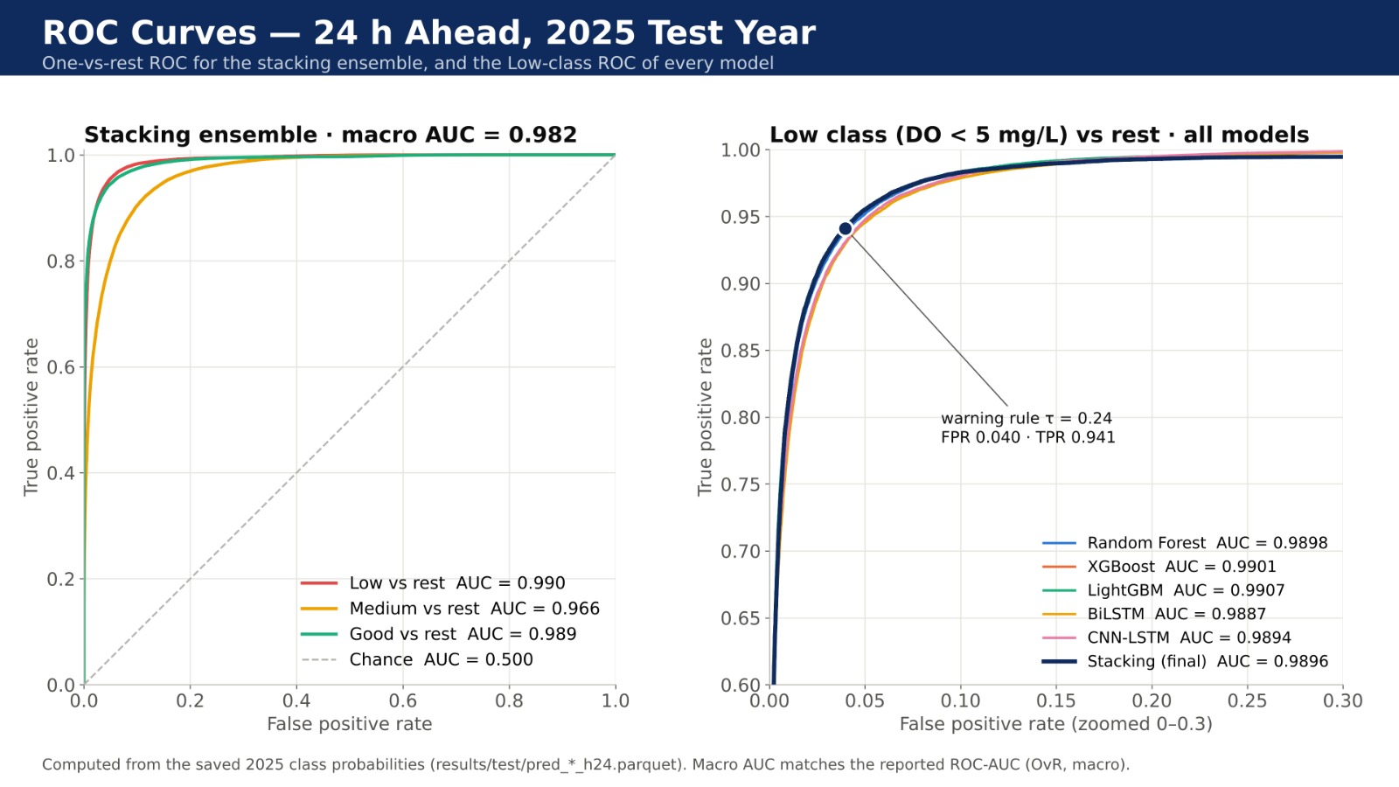
Figure 4.3: ROC Curve Analysis of the Proposed Model.
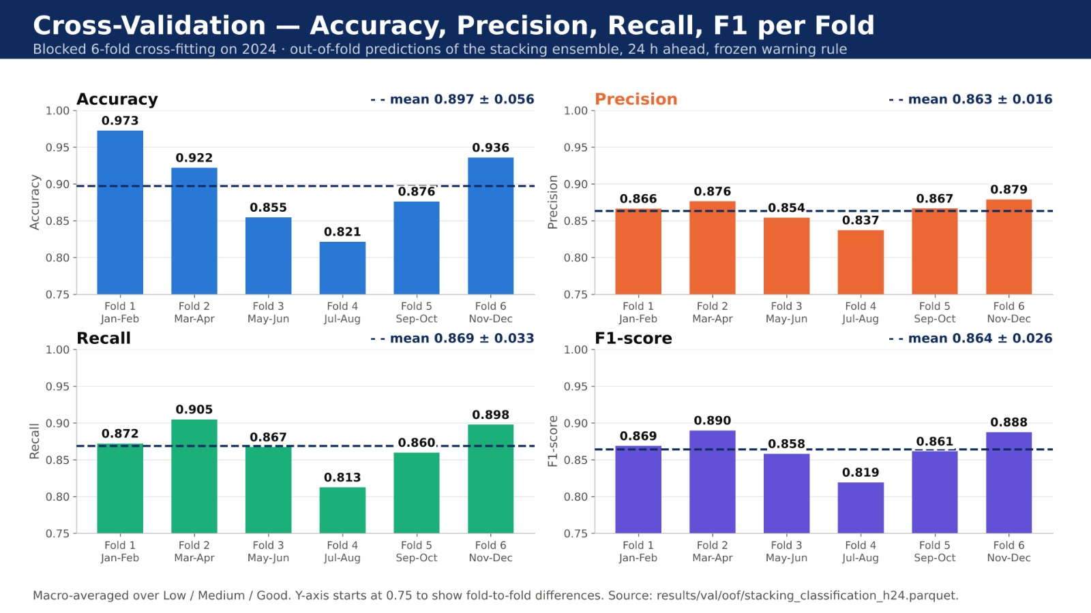
Figure 4.4: Cross-Validation Performance Across Six Folds.

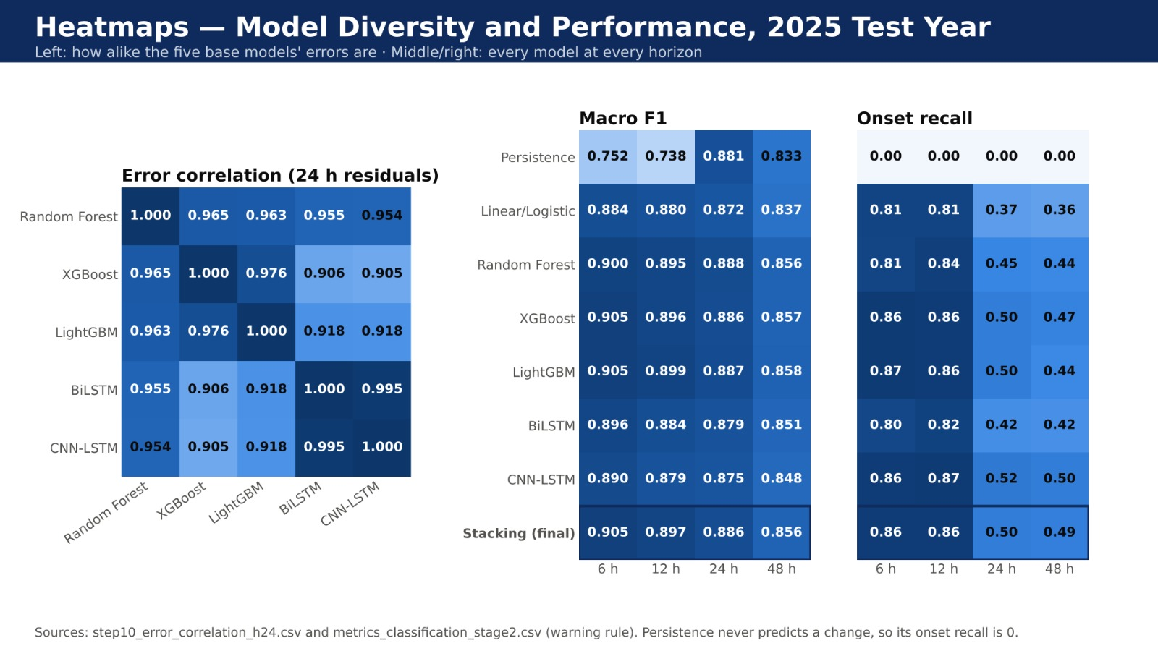
Figure 4.5: Model Error Correlation and Performance Heatmaps.

Chapter 5
CONCLUSION
The project titled “Machine Learning Framework for Early Warning of Dissolved-Oxygen Deterioration in Rivers” focuses on developing a machine learning-based framework for predicting river dissolved-oxygen conditions. The primary objective of the proposed system is to support early identification of potentially deteriorating water quality by classifying dissolved-oxygen levels into three categories: Low, Medium, and Good. The framework evaluates multiple machine learning and deep learning models to predict water-quality conditions at different forecast horizons.
The system incorporates Random Forest, XGBoost, LightGBM, BiLSTM, and CNN-LSTM models, along with a stacking ensemble that combines their predictions. A persistence baseline and a Linear/Logistic Regression model are also used for comparison. The framework evaluates predictions at 6-hour, 12-hour, 24-hour, and 48-hour horizons, allowing its performance to be assessed over both shorter and longer forecasting periods. Accuracy, precision, recall, F1-score, confusion matrices, ROC curves, and cross-validation are used to examine the classification performance.
The models were evaluated on unseen data from the year 2025, covering 30 river monitoring stations and approximately 251,000 hourly forecasts per prediction horizon. At the 24-hour forecast horizon, the proposed stacking ensemble achieved an accuracy of approximately 90.4%, precision of 87.8%, recall of 89.6%, and an F1-score of 88.6%. Its strongest performance was observed at the 6-hour horizon, with an accuracy of approximately 92.1% and an F1-score of 90.5%. The results indicate that classification performance decreases as the forecast horizon increases, with an accuracy of approximately 87.6% at 48 hours ahead.
The experimental results demonstrate that the proposed framework provides a promising approach to forecasting river dissolved-oxygen conditions. The confusion matrix analysis showed that Low and Good dissolved-oxygen categories were generally classified more accurately than the Medium category. Although the ROC analysis indicated strong class-discrimination performance, cross-validation and event-based evaluation highlighted areas requiring further improvement. In particular, improving the detection of newly developing low-dissolved-oxygen conditions and reducing missed warning events are important for strengthening the framework's early-warning capability.
In conclusion, the project demonstrates the potential of combining machine learning and deep learning techniques for multi-horizon river-water-quality forecasting. Future enhancements may include improving the detection of deterioration events, reducing errors shared by different models, incorporating additional environmental information where beneficial, and evaluating the framework across more river stations and independent time periods. With further testing and validation, the proposed system could support river monitoring by providing advance predictions of potentially deteriorating dissolved-oxygen conditions. However, its predictions should be used as a decision-support aid alongside actual water-quality measurements and expert assessment, rather than as a replacement for environmental monitoring.

Chapter 6
FUTURE ENHANCEMENT
The proposed system can be further enhanced to improve the prediction of dissolved-oxygen deterioration in rivers. Additional environmental parameters, such as water temperature, rainfall, river flow, and atmospheric conditions, can be explored to improve forecasting performance. Incorporating more reliable and diverse environmental data may help the system identify patterns associated with declining dissolved-oxygen levels and improve predictions across different river conditions.
Future work can focus on improving the performance of the existing machine learning and deep learning models. Advanced hyperparameter optimization techniques, such as Grid Search, Random Search, and Bayesian Optimization, can be explored to identify suitable model configurations. The stacking ensemble can also be improved by optimizing the combination of Random Forest, XGBoost, LightGBM, BiLSTM, and CNN-LSTM to determine whether better classification performance can be achieved.
The framework can be extended to include more river monitoring stations and longer historical datasets. Evaluating the system across different geographical locations, seasons, and environmental conditions would help assess its ability to generalize to different rivers. Further testing on independent datasets can also help determine the reliability of the framework under changing water-quality conditions.
An interactive dashboard can be enhanced to display predicted dissolved-oxygen categories, forecast horizons, warning levels, and historical water-quality trends. Explainable Artificial Intelligence techniques, such as SHAP (SHapley Additive Explanations), can be incorporated to identify the environmental features that influence model predictions. These features can help users understand the factors associated with predicted dissolved-oxygen deterioration and make the system's outputs easier to interpret.
Another important future enhancement is improving the detection of deterioration events and reducing missed warnings. Although the current framework achieves promising classification results, identifying the onset of low dissolved-oxygen conditions remains an important challenge. Future work can explore alternative warning thresholds, probability calibration, class-balancing techniques, and event-based evaluation methods to improve warning detection while controlling false alarms. The system can also be assessed using warning lead time to determine how early it identifies potential deterioration events.
Furthermore, the framework can be extended to support continuous monitoring and regular model evaluation as new water-quality data becomes available. Automated data updates, periodic retraining, and performance monitoring can help maintain prediction quality over time. Integrating real-time sensor data and automated alert notifications may also improve the usefulness of the system for practical river monitoring.
Finally, the proposed framework can be validated through further testing with environmental monitoring experts and independent river datasets. These enhancements can improve the system's reliability, scalability, and usefulness for water-quality assessment. With continued development, the framework has the potential to support environmental authorities and river-monitoring teams by providing advance predictions of potentially deteriorating dissolved-oxygen conditions and assisting in timely environmental assessment.

Chapter 7
SOURCE CODE

- Data Acquisition from USGS NWIS and Open-Meteo
Downloads hourly water-quality readings (DO, temperature, conductivity, pH, turbidity, discharge) from the USGS National Water Information System and the matching ERA5 weather and CAMS air-quality series from Open-Meteo for every station, with automatic retries for unreliable network calls.
File: src/data/download.py
def get(url, params, tries=None, timeout=None):
tries = tries or DL["retries"]
timeout = timeout or DL["timeout"]
for k in range(tries):
try:
r = session.get(url, params=params, timeout=timeout)
if r.status_code == 200:
return r
# 400/404 mean "no such data" - retrying will not help.
if r.status_code in (400, 404):
return r
print(f" HTTP {r.status_code} (try {k + 1}/{tries})")
except requests.RequestException as e:
print(f" network error: {e} (try {k + 1}/{tries})")
time.sleep(3 * (k + 1))
print(f" giving up on {url}")
return None

def fetch_water(site, start, end):
frames = []
for year in range(pd.Timestamp(start).year, pd.Timestamp(end).year + 1):
y_start = max(pd.Timestamp(start), pd.Timestamp(f"{year}-01-01"))
y_end = min(pd.Timestamp(end), pd.Timestamp(f"{year}-12-31"))
if y_start > y_end:
continue
r = get(DL["urls"]["usgs_iv"], {
"format": "json", "sites": site,
"parameterCd": ",".join(PARAMS),
"startDT": y_start.strftime("%Y-%m-%d"),
"endDT": y_end.strftime("%Y-%m-%d"),
"siteStatus": "all"})
if r is None or r.status_code != 200:
continue
try:
series = r.json()["value"]["timeSeries"]
except Exception:
continue
for ts in series:
code = ts["variable"]["variableCode"][0]["value"]
if code not in PARAMS:
continue
nodata = ts["variable"].get("noDataValue", -999999)
for block in ts["values"]:
if not block["value"]:
continue
d = pd.DataFrame(block["value"])[["dateTime", "value"]]
d["value"] = pd.to_numeric(d["value"], errors="coerce")
d.loc[d["value"] == nodata, "value"] = None
d["time"] = pd.to_datetime(d["dateTime"], utc=True, format="mixed")
d["param"] = PARAMS[code]
frames.append(d[["time", "param", "value"]])
if not frames:
return None
long = pd.concat(frames)
# one parameter can have several sensors at a site -> average them
wide = (long.groupby(["time", "param"])["value"].mean()
.unstack("param").sort_index())
wide.index = wide.index.tz_convert("UTC").tz_localize(None)
wide.index.name = "time"
return wide

def fetch_open_meteo(kind, lat, lon, start, end):
url = DL["urls"]["open_meteo_weather" if kind == "weather" else "open_meteo_air"]
vars_ = DL["weather_vars" if kind == "weather" else "air_vars"]
r = get(url, {"latitude": lat, "longitude": lon,
"start_date": pd.Timestamp(start).strftime("%Y-%m-%d"),
"end_date": pd.Timestamp(end).strftime("%Y-%m-%d"),
"hourly": ",".join(vars_), "timezone": "GMT"})
if r is None or r.status_code != 200:
print(f" {kind} download failed")
return None
try:
df = pd.DataFrame(r.json()["hourly"])
except Exception:
return None
df["time"] = pd.to_datetime(df["time"])
time.sleep(DL["sleep_between_calls"]) # be polite to the free API
return df.set_index("time").sort_index()

2. Causal Data Cleaning and Gap Handling
Resamples 15-minute sensor readings to hourly means, removes physically impossible values and short DO spikes, records a missing-value mask before any filling, and fills only gaps of up to 3 hours by carrying the last observed value forward, so that no filled value can contain information from the future.
File: src/data/clean.py
def to_hourly(path, index=None):
df = pd.read_csv(path, parse_dates=["time"]).set_index("time").sort_index()
df = df.apply(pd.to_numeric, errors="coerce")
hourly = df.resample(CL["resample_rule"]).mean()
return hourly.reindex(FULL_INDEX if index is None else index)

def apply_ranges(df):
n_removed = {}
for var, rng in CL["valid_ranges"].items():
if var not in df.columns:
continue
col = df[var]
bad = pd.Series(False, index=df.index)
if rng.get("min") is not None:
bad |= (col <= rng["min"]) if rng.get("min_exclusive") else (col < rng["min"])
if rng.get("max") is not None:
bad |= col > rng["max"]
bad &= col.notna()
if bad.any():
df.loc[bad, var] = np.nan
n_removed[var] = int(bad.sum())
return df, n_removed

def remove_spikes(df):
spike_cfg = CL["spike"]
limit = spike_cfg["max_change"]
window = int(spike_cfg["reversal_hours"])
n_removed = {}
for var in spike_cfg["columns"]:
if var not in df.columns:
continue
col = df[var]
jump = col.diff() # change from the previous hour
# does the jump reverse within the next `window` hours?
reverses = pd.Series(False, index=col.index)
for k in range(1, window + 1):
back = col.shift(-k) - col # change from t to t+k
reverses |= (jump.abs() > limit) & (back.abs() > limit) & \
(np.sign(back) == -np.sign(jump))
spike = reverses & col.notna()
if spike.any():
df.loc[spike, var] = np.nan
n_removed[var] = int(spike.sum())
return df, n_removed

def fill_short_gaps(df, cols):
limit = int(CL["max_gap_fill_hours"])
method = CL.get("gap_fill_method", "ffill")
if method != "ffill":
raise ValueError(f"cleaning.gap_fill_method must be 'ffill', got {method!r}")
if limit <= 0:
return df
for c in cols:
if c not in df.columns:
continue
col = df[c]
if col.notna().sum() == 0:
continue
# ffill with a limit only carries a value forward `limit` rows, so a
# longer gap keeps its NaNs from hour limit+1 onwards automatically.
df[c] = col.ffill(limit=limit)
return df

3. Feature Engineering and Target Construction
Builds the 211 strictly causal features (lags, rolling statistics, rates of change, daily DO swing, hours since the last low-oxygen reading, DO saturation, weather, air-quality and cyclic time features) and the regression and three-class targets (Low < 5, Medium 5–7, Good > 7 mg/L) at 6, 12, 24 and 48 hours ahead.
File: src/features/build_features.py
def hours_since_true(flag, cap):
position = np.arange(len(flag))
last = pd.Series(np.where(flag.to_numpy(), position, np.nan),
index=flag.index).ffill()
since = pd.Series(position, index=flag.index) - last
return since.fillna(cap).clip(upper=cap)

def do_solubility(temp_c):
t_k = temp_c + 273.15
with np.errstate(invalid="ignore", divide="ignore"):
ln_dos = (-139.34411
+ 1.575701e5 / t_k
- 6.642308e7 / t_k ** 2
+ 1.243800e10 / t_k ** 3
- 8.621949e11 / t_k ** 4)
return np.exp(ln_dos)

def water_features(df, out):
for v in WATER_VARS:
col = df[v]
out[v] = col # value at t
for k in F["water_lags"]:
out[f"{v}_lag{k}"] = col.shift(k)
for w in F["water_roll_windows"]:
roll = col.rolling(w, min_periods=1) # includes t, never t+1
for stat in F["water_roll_stats"]:
if stat == "std":
# std needs at least two values to mean anything
out[f"{v}_roll{w}_std"] = col.rolling(w, min_periods=2).std()
else:
out[f"{v}_roll{w}_{stat}"] = getattr(roll, stat)()
for k in F["water_diffs"]:
out[f"{v}_chg{k}"] = col - col.shift(k)
# the cleaning step's "was there a reading this hour" flag
out[v + MASK] = df[v + MASK]

def do_features(df, out):
do = df[DO]
win = F["do_swing_window"]
out[f"do_swing{win}"] = (do.rolling(win, min_periods=1).max()
- do.rolling(win, min_periods=1).min())
low = do < LOW # NaN counts as "not low"
out["do_hours_since_low"] = hours_since_true(low, F["hours_since_low_cap"])
lw = F["do_low_hours_window"]
out[f"do_low_hours_{lw}"] = low.rolling(lw, min_periods=1).sum()
if F["do_saturation"]:
out["do_saturation"] = do / do_solubility(df["water_temp_c"])

def weather_features(df, out):
for v in WEATHER_VARS:
col = df[v]
out[v] = col
for k in F["weather_lags"]:
out[f"{v}_lag{k}"] = col.shift(k)
w24 = F["weather_roll24_window"]
for v in F["weather_roll24_vars"]:
out[f"{v}_roll{w24}_mean"] = df[v].rolling(w24, min_periods=1).mean()
rain = df[F["precip_var"]]
for w in F["precip_sum_windows"]:
out[f"precip_sum{w}"] = rain.rolling(w, min_periods=1).sum()
out["hours_since_rain"] = hours_since_true(rain > F["rain_threshold_mm"],
F["hours_since_rain_cap"])

def air_features(df, out):
w = F["air_roll_window"]
for v in AIR_VARS:
out[v] = df[v]
out[f"{v}_roll{w}_mean"] = df[v].rolling(w, min_periods=1).mean()

def time_features(df, out):
t = df.index
hour, doy = t.hour.to_numpy(), t.dayofyear.to_numpy()
out["hour_sin"] = pd.Series(np.sin(2 * np.pi * hour / 24), index=t)
out["hour_cos"] = pd.Series(np.cos(2 * np.pi * hour / 24), index=t)
out["doy_sin"] = pd.Series(np.sin(2 * np.pi * doy / 365.25), index=t)
out["doy_cos"] = pd.Series(np.cos(2 * np.pi * doy / 365.25), index=t)
out["month"] = pd.Series(t.month.to_numpy(), index=t)

def targets(df, out):
observed = df[DO].where(df[DO + MASK] == 0)
for h in HORIZONS:
y = observed.shift(-h)
out[f"y_reg_{h}"] = y
# 0 = Low, 1 = Medium, 2 = Good; NaN stays NaN
cls = pd.Series(np.nan, index=y.index)
cls[y < LOW] = 0
cls[(y >= LOW) & (y <= GOOD)] = 1
cls[y > GOOD] = 2
out[f"y_cls_{h}"] = cls

4. Machine Learning Models: Random Forest, XGBoost and LightGBM
Trains the three tree-based base learners on the tabular feature matrix for both tasks (DO regression and Low/Medium/Good classification), with class-balanced weights and early stopping monitored on the 2024 validation year.
File: src/models/train_ml.py
def fit_random_forest(task, X_tr, y_tr, X_val, features):
from sklearn.ensemble import RandomForestClassifier, RandomForestRegressor
from sklearn.impute import SimpleImputer
from sklearn.pipeline import Pipeline

cfg = dict(C.M["random_forest"])
class_weight = cfg.pop("classifier_class_weight")
if task == "regression":
rf = RandomForestRegressor(random_state=C.SEED, **cfg)
else:
rf = RandomForestClassifier(random_state=C.SEED,
class_weight=class_weight, **cfg)
model = Pipeline([("impute", SimpleImputer(strategy="median")),
("model", rf)])
model.fit(X_tr, y_tr)

pred = model.predict(X_val)
proba = model.predict_proba(X_val) if task == "classification" else None
importance = model.named_steps["model"].feature_importances_
return model, pred, proba, importance, {"n_trees": cfg["n_estimators"]}

def fit_xgboost(task, X_tr, y_tr, X_val, y_val_fit, features):
from xgboost import XGBClassifier, XGBRegressor

cfg = dict(C.M["xgboost"])
common = dict(n_estimators=C.M["max_rounds"],
early_stopping_rounds=C.M["early_stopping_rounds"],
random_state=C.SEED, **cfg)
X_val_fit, y_val_ok = y_val_fit
weights = None
if task == "regression":
model = XGBRegressor(eval_metric="rmse", **common)
else:
model = XGBClassifier(objective="multi:softprob", num_class=3,
eval_metric="mlogloss", **common)
weights = C.balanced_sample_weight(y_tr)

model.fit(X_tr, y_tr, sample_weight=weights,
eval_set=[(X_val_fit, y_val_ok)], verbose=False)

pred = model.predict(X_val)
proba = model.predict_proba(X_val) if task == "classification" else None
return (model, pred, proba, model.feature_importances_,
{"best_iteration": int(model.best_iteration)})

def fit_lightgbm(task, X_tr, y_tr, X_val, y_val_fit, features):
import lightgbm as lgb

cfg = dict(C.M["lightgbm"])
cat_cols = cfg.pop("categorical_features")
class_weight = cfg.pop("classifier_class_weight")
cats = {c: sorted(X_tr[c].astype("int32").unique()) for c in cat_cols
if c in X_tr.columns}
X_tr_l = as_lgbm_frame(X_tr, cats)
X_val_l = as_lgbm_frame(X_val, cats)
X_val_fit, y_val_ok = y_val_fit
X_val_fit_l = as_lgbm_frame(X_val_fit, cats)

common = dict(n_estimators=C.M["max_rounds"], random_state=C.SEED,
verbose=-1, **cfg)
if task == "regression":
model = lgb.LGBMRegressor(objective="regression", **common)
else:
model = lgb.LGBMClassifier(objective="multiclass", num_class=3,
class_weight=class_weight, **common)

model.fit(X_tr_l, y_tr, eval_set=[(X_val_fit_l, y_val_ok)],
callbacks=[lgb.early_stopping(C.M["early_stopping_rounds"],
verbose=False),
lgb.log_evaluation(0)])

pred = model.predict(X_val_l)
proba = model.predict_proba(X_val_l) if task == "classification" else None
return (model, pred, proba, model.feature_importances_,
{"best_iteration": int(model.best_iteration_ or 0)})

5. Deep Learning Architectures: BiLSTM and CNN-LSTM
Defines the two multi-task sequence networks. Each reads a 72-hour window of raw hourly inputs, adds a station embedding and a dense branch over the engineered features, and outputs four DO forecasts and four sets of class probabilities through shared heads. The loss combines mean squared error and class-weighted cross-entropy.
File: src/models/dl_models.py
class FeatureBranch(nn.Module):

def __init__(self, n_features, hidden, dropout):
super().__init__()
self.net = nn.Sequential(
nn.Linear(n_features, hidden),
nn.ReLU(),
nn.Dropout(dropout),
)
self.out_features = hidden

def forward(self, f):
return self.net(f)

class Heads(nn.Module):

def __init__(self, in_features, dense_size, dropout):
super().__init__()
self.body = nn.Sequential(
nn.Linear(in_features, dense_size),
nn.ReLU(),
nn.Dropout(dropout),
)
self.regression = nn.Linear(dense_size, N_HORIZONS)
self.classification = nn.Linear(dense_size, N_HORIZONS * N_CLASSES)

def forward(self, z):
z = self.body(z)
reg = self.regression(z) # (B, 4)
cls = self.classification(z) # (B, 12)
return reg, cls.view(-1, N_HORIZONS, N_CLASSES)

class BiLSTM(nn.Module):

name = "bilstm"

def __init__(self, n_channels, n_stations, cfg=None, n_features=0):
super().__init__()
c = dict(CFG["models"]["bilstm"])
c.update(cfg or {})
self.embedding = nn.Embedding(n_stations, DL["station_embedding_dim"])
self.lstm = nn.LSTM(
input_size=n_channels, hidden_size=c["hidden_size"],
num_layers=c["num_layers"], bidirectional=c["bidirectional"],
dropout=c["dropout"] if c["num_layers"] > 1 else 0.0,
batch_first=True)
directions = 2 if c["bidirectional"] else 1
width = c["hidden_size"] * directions + DL["station_embedding_dim"]
self.features = None
if n_features:
self.features = FeatureBranch(n_features, c.get("feature_hidden", 64),
c["dropout"])
width += self.features.out_features
self.heads = Heads(width, c["dense_size"], c["dropout"])
self.directions = directions

def forward(self, x, station, features=None):
# h_n is (num_layers * directions, batch, hidden)
_, (h_n, _) = self.lstm(x)
if self.directions == 2:
last = torch.cat([h_n[-2], h_n[-1]], dim=1) # forward + backward
else:
last = h_n[-1]
parts = [last, self.embedding(station)]
if self.features is not None:
parts.append(self.features(features))
return self.heads(torch.cat(parts, dim=1))

class CNNLSTM(nn.Module):

name = "cnn_lstm"

def __init__(self, n_channels, n_stations, cfg=None, n_features=0):
super().__init__()
c = dict(CFG["models"]["cnn_lstm"])
c.update(cfg or {})
ch1, ch2 = c["conv_channels"]
k = c["kernel_size"]
self.embedding = nn.Embedding(n_stations, DL["station_embedding_dim"])
# Conv1d wants (batch, channels, time), so the input is transposed.
# padding keeps the length at 48 before pooling.
self.conv = nn.Sequential(
nn.Conv1d(n_channels, ch1, kernel_size=k, padding=k // 2),
nn.ReLU(),
nn.Conv1d(ch1, ch2, kernel_size=k, padding=k // 2),
nn.ReLU(),
nn.MaxPool1d(c["pool_size"]),
)
self.lstm = nn.LSTM(input_size=ch2, hidden_size=c["hidden_size"],
num_layers=c["num_layers"], batch_first=True)
width = c["hidden_size"] + DL["station_embedding_dim"]
self.features = None
if n_features:
self.features = FeatureBranch(n_features, c.get("feature_hidden", 64),
c["dropout"])
width += self.features.out_features
self.heads = Heads(width, c["dense_size"], c["dropout"])

def forward(self, x, station, features=None):
z = self.conv(x.transpose(1, 2)) # (B, channels, time/2)
_, (h_n, _) = self.lstm(z.transpose(1, 2))
parts = [h_n[-1], self.embedding(station)]
if self.features is not None:
parts.append(self.features(features))
return self.heads(torch.cat(parts, dim=1))

class MultiTaskLoss(nn.Module):

def __init__(self, class_weights, cls_weight=None):
super().__init__()
self.register_buffer("class_weights", torch.as_tensor(class_weights,
dtype=torch.float32))
self.cls_weight = (DL["classification_loss_weight"]
if cls_weight is None else cls_weight)

def forward(self, reg_out, cls_out, reg_target, cls_target):
reg_ok = ~torch.isnan(reg_target)
if reg_ok.any():
diff = (reg_out - torch.nan_to_num(reg_target)) ** 2
# mean per horizon over the rows that have a target, then over horizons
per_h = (diff * reg_ok).sum(0) / reg_ok.sum(0).clamp(min=1)
reg_loss = per_h[reg_ok.any(0)].mean()
else:
reg_loss = reg_out.sum() * 0.0

cls_losses = []
for h in range(cls_out.shape[1]):
ok = cls_target[:, h] >= 0
if not ok.any():
continue
loss_h = nn.functional.cross_entropy(
cls_out[ok, h, :], cls_target[ok, h].long(),
weight=self.class_weights[h])
cls_losses.append(loss_h)
cls_loss = (torch.stack(cls_losses).mean() if cls_losses
else cls_out.sum() * 0.0)

total = reg_loss + self.cls_weight * cls_loss
return total, reg_loss.detach(), cls_loss.detach()

6. Deep Learning Training Loop (GPU, Mixed Precision)
One training or evaluation pass over the data on the RTX 3050 GPU, using automatic mixed precision, gradient scaling and gradient clipping, with the Adam/AdamW optimiser selected from the configuration.
File: src/models/train_dl.py
def run_epoch(model, data, reg_t, cls_t, loss_fn, device, batch_size,
optimizer=None, scaler=None, use_amp=False, shuffle=False):
training = optimizer is not None
model.train(training)
order = np.arange(len(data))
if shuffle:
np.random.shuffle(order)

pin = device.type == "cuda" and DL["pin_memory"]
total, n_batches = 0.0, 0
reg_pred = np.empty((len(data), len(HORIZONS)), dtype="float32")
cls_prob = np.empty((len(data), len(HORIZONS), N_CLASSES), dtype="float32")

for start in range(0, len(order), batch_size):
ids = order[start:start + batch_size]
x, station, feats = data.batch(ids)
xt, st = torch.from_numpy(x), torch.from_numpy(station)
ft = None if feats is None else torch.from_numpy(feats)
if pin:
xt, st = xt.pin_memory(), st.pin_memory()
ft = None if ft is None else ft.pin_memory()
xt = xt.to(device, non_blocking=True)
st = st.to(device, non_blocking=True)
ft = None if ft is None else ft.to(device, non_blocking=True)
rt = torch.from_numpy(reg_t[ids]).to(device, non_blocking=True)
ct = torch.from_numpy(cls_t[ids]).to(device, non_blocking=True)

with torch.set_grad_enabled(training):
with torch.autocast(device_type=device.type, dtype=torch.float16,
enabled=use_amp):
reg_out, cls_out = model(xt, st, ft)
loss, _, _ = loss_fn(reg_out.float(), cls_out.float(), rt, ct)

if training:
optimizer.zero_grad(set_to_none=True)
if use_amp:
scaler.scale(loss).backward()
scaler.unscale_(optimizer) # unscale BEFORE clipping
torch.nn.utils.clip_grad_norm_(model.parameters(),
DL["grad_clip"])
scaler.step(optimizer)
scaler.update()
else:
loss.backward()
torch.nn.utils.clip_grad_norm_(model.parameters(),
DL["grad_clip"])
optimizer.step()
else:
reg_pred[ids] = reg_out.float().cpu().numpy()
cls_prob[ids] = torch.softmax(cls_out.float(), dim=2).cpu().numpy()

total += float(loss.item())
n_batches += 1

return total / max(n_batches, 1), reg_pred, cls_prob

def make_optimizer(model, settings):
lr = settings["learning_rate"]
if settings.get("optimizer", "adam").lower() == "adamw":
return torch.optim.AdamW(model.parameters(), lr=lr,
weight_decay=settings.get("weight_decay", 0.0))
return torch.optim.Adam(model.parameters(), lr=lr)

7. Blocked Cross-Fitting with Purge
Divides the 2024 validation year into six two-month folds. Each fold is predicted by a meta-model fitted on the other five, and rows within 14 days of the held-out fold are purged from training so that no 48-hour target or error window crosses a fold boundary.
File: src/models/crossfit.py
def fold_of(times):
t = pd.to_datetime(pd.Series(np.asarray(times)).reset_index(drop=True))
year = CFG["split"]["val_years"][0]
months_per_fold = int(CV["months_per_fold"])
fold = ((t.dt.month - 1) // months_per_fold).to_numpy()
fold = np.where(t.dt.year.to_numpy() == year, fold, -1)
return fold.astype(int)

def fold_bounds(fold_id):
year = CFG["split"]["val_years"][0]
m = int(CV["months_per_fold"])
start = pd.Timestamp(year=year, month=fold_id * m + 1, day=1)
end = start + pd.DateOffset(months=m) - pd.Timedelta(seconds=1)
return start, end

def split_indices(times, fold_id):
t = pd.to_datetime(pd.Series(np.asarray(times)).reset_index(drop=True))
folds = fold_of(times)
start, end = fold_bounds(fold_id)
purge = pd.Timedelta(days=int(CV["purge_days"]))

test = np.flatnonzero(folds == fold_id)
in_year = folds >= 0
too_close = ((t >= start - purge) & (t <= end + purge)).to_numpy()
train = np.flatnonzero(in_year & ~too_close)
return train, test

8. Stacking Ensemble Meta-Learner
Combines the five base models: Ridge regression on the five DO forecasts gives the final DO value, and class-balanced multinomial logistic regression on the fifteen class probabilities gives the final Low/Medium/Good probabilities. The second function applies the frozen meta-learner at prediction time.
File: src/models/ensemble.py, src/models/predict_service.py
def stacking(task, reg, proba, y_reg, y_cls, mask_a):
from sklearn.linear_model import LogisticRegression, Ridge
if task == "regression":
X, y = reg, y_reg
ok = mask_a & ~np.isnan(y) & ~np.isnan(X).any(axis=1)
model = Ridge(alpha=1.0).fit(X[ok], y[ok])
return model.predict(X), model
X = proba.reshape(len(proba), -1)
y = y_cls
ok = mask_a & ~np.isnan(y) & ~np.isnan(X).any(axis=1)
model = LogisticRegression(max_iter=1000, multi_class="multinomial",
class_weight="balanced",
random_state=CFG["seed"]).fit(X[ok], y[ok].astype(int))
out = model.predict_proba(X)
if out.shape[1] < N_CLASSES: # a class missing on val-A
full = np.zeros((len(out), N_CLASSES))
full[:, model.classes_.astype(int)] = out
out = full
return out, model

def _stack(self, task, h, reg, proba):
import joblib
path = os.path.join(project_path(CFG["context_ensemble"]["model_dir"]),
f"stacking_{task}_h{h}_final.joblib")
model = joblib.load(path)["model"]
if task == "regression":
return model.predict(reg)
out = model.predict_proba(proba.reshape(len(proba), -1))
if out.shape[1] < 3:
full = np.zeros((len(out), 3))
full[:, model.classes_.astype(int)] = out
out = full
return out
9. Early-Warning Rule and Threshold Selection
Raises a warning when P(Low) reaches a horizon-specific threshold τ instead of taking the most likely class. τ is chosen on the out-of-fold 2024 probabilities as the value that catches the most onsets while keeping the false-alarm rate within 1.8% (the 2% limit minus a safety margin).
File: src/models/run_step7.py, src/models/freeze.py
def apply_warning(proba, tau):
pred = 1 + proba[:, 1:].argmax(axis=1)
pred[proba[:, 0] >= tau] = 0
return pred

def choose_tau_oof(proba, y_cls, class_now, budget=BUDGET):
best = None
for tau in R.tau_grid():
pred = R.apply_warning(proba, tau)
m = early_warning_metrics(class_now, y_cls, pred)
rate, recall = m["false_alarm_rate"], m["onset_recall"]
if np.isnan(rate) or np.isnan(recall) or rate > budget:
continue
key = (recall, -rate, tau)
if best is None or key > best[0]:
best = (key, float(tau), float(recall), float(rate))
if best is None:
return {"tau": None, "rule": "argmax", "onset_recall_2024": np.nan,
"false_alarm_2024": np.nan}
return {"tau": best[1], "rule": "P(Low) >= tau",
"onset_recall_2024": best[2], "false_alarm_2024": best[3]}

def sha256(path):
h = hashlib.sha256()
with open(path, "rb") as f:
for chunk in iter(lambda: f.read(1 << 20), b""):
h.update(chunk)
return h.hexdigest()

10. Evaluation Metrics
Computes the regression metrics (RMSE, MAE, R², NSE, skill against persistence), the classification metrics (accuracy, balanced accuracy, macro precision, recall and F1, ROC-AUC, confusion matrix), the early-warning metrics (onset recall, false-alarm rate) and the event lead time used in Chapter 4.
File: src/evaluation/metrics.py, src/evaluation/test_2025.py
def regression_metrics(y_true, y_pred, y_persistence=None):
ok = valid_mask(y_true, y_pred, y_persistence)
y = as_float(y_true)[ok]
p = as_float(y_pred)[ok]
n = len(y)
if n == 0:
return {"n": 0, "r2": np.nan, "rmse": np.nan, "mae": np.nan,
"nse": np.nan, "skill_vs_persistence": np.nan}

errors = p - y
sse = float(np.sum(errors ** 2))
sst = float(np.sum((y - y.mean()) ** 2)) # variance of the truth

rmse = float(np.sqrt(sse / n))
mae = float(np.mean(np.abs(errors)))
# R2 and NSE are the same formula here; both are reported because the ML
# literature asks for R2 and the hydrology literature for NSE.
r2 = 1 - sse / sst if sst > 0 else np.nan
nse = r2

skill = np.nan
if y_persistence is not None:
q = as_float(y_persistence)[ok]
rmse_p = float(np.sqrt(np.mean((q - y) ** 2)))
skill = 1 - rmse / rmse_p if rmse_p > 0 else np.nan

return {"n": n, "r2": r2, "rmse": rmse, "mae": mae, "nse": nse,
"skill_vs_persistence": skill}

def classification_metrics(y_true, y_pred, y_proba=None):
ok = valid_mask(y_true, y_pred, y_proba)
y = as_float(y_true)[ok].astype(int)
p = as_float(y_pred)[ok].astype(int)
labels = list(range(N_CLASSES))
if len(y) == 0:
empty = {f"{m}_{c}": np.nan for c in CLASS_NAMES
for m in ["precision", "recall", "f1"]}
return {"n": 0, "accuracy": np.nan, "balanced_accuracy": np.nan,
"precision_macro": np.nan, "recall_macro": np.nan,
"f1_macro": np.nan, "roc_auc_ovr_macro": np.nan,
"confusion_matrix": np.zeros((N_CLASSES, N_CLASSES), int),
**empty}

out = {
"n": len(y),
"accuracy": float(accuracy_score(y, p)),
"balanced_accuracy": float(balanced_accuracy_score(y, p)),
# zero_division=0: a class a model never predicts scores 0, not an error
"precision_macro": float(precision_score(y, p, labels=labels,
average="macro", zero_division=0)),
"recall_macro": float(recall_score(y, p, labels=labels,
average="macro", zero_division=0)),
"f1_macro": float(f1_score(y, p, labels=labels,
average="macro", zero_division=0)),
}

# per class, in the order Low, Medium, Good
per = {m: f(y, p, labels=labels, average=None, zero_division=0)
for m, f in [("precision", precision_score), ("recall", recall_score),
("f1", f1_score)]}
for i, name in enumerate(CLASS_NAMES):
for m in per:
out[f"{m}_{name}"] = float(per[m][i])

# ROC-AUC needs probabilities and at least two classes actually present
out["roc_auc_ovr_macro"] = np.nan
if y_proba is not None and len(np.unique(y)) > 1:
proba = as_float(y_proba)[ok]
try:
out["roc_auc_ovr_macro"] = float(
roc_auc_score(y, proba, multi_class="ovr", average="macro",
labels=labels))
except ValueError:
pass # not all classes present: leave it as NaN

out["confusion_matrix"] = confusion_matrix(y, p, labels=labels)
return out

def early_warning_metrics(class_now, y_true, y_pred):
low = 0
ok = valid_mask(y_true, y_pred, class_now)
now = as_float(class_now)[ok].astype(int)
true = as_float(y_true)[ok].astype(int)
pred = as_float(y_pred)[ok].astype(int)

changed = true != now
not_low_now = now != low
onset = not_low_now & (true == low) # the water turns dangerous
stays_safe = not_low_now & (true != low)
predicted_low = not_low_now & (pred == low)

def share(numerator, denominator):
n = int(denominator.sum())
return (float(numerator.sum()) / n) if n else float("nan")

return {
"n_transitions": int(changed.sum()),
"transition_accuracy": share(changed & (pred == true), changed),
"n_onsets": int(onset.sum()),
"onset_recall": share(onset & (pred == low), onset),
"onset_precision": share(predicted_low & (true == low), predicted_low),
"false_alarm_rate": share(stays_safe & (pred == low), stays_safe),
}

def lead_times(keys, y_reg_now, warn_flags, h=24, window=None):
recovery = FT["event_recovery_hours"]
window = window or FT["lead_time_window_hours"]
out = []
df = pd.DataFrame({"station": keys["station"].to_numpy(),
"time": pd.to_datetime(keys["time"].to_numpy()),
"do": y_reg_now, "warn": warn_flags})
for station, g in df.groupby("station", sort=True):
g = g.sort_values("time").reset_index(drop=True)
below = g["do"] < LOW
recovered = g["do"].notna() & (g["do"] >= LOW)
run = recovered.rolling(recovery, min_periods=1).sum()
prev = run.shift(1).fillna(recovery)
starts = np.flatnonzero((below & (prev >= recovery)).to_numpy())
for s in starts:
onset_time = g["time"].iloc[s]
lo = onset_time - pd.Timedelta(hours=window)
prior = g[(g["time"] >= lo) & (g["time"] < onset_time)]
fired = prior[prior["warn"] == 1]
if len(fired):
lead = (onset_time - fired["time"].iloc[0]).total_seconds() / 3600
out.append({"station": station, "onset": onset_time,
"warned": True, "lead_hours": lead})
else:
out.append({"station": station, "onset": onset_time,
"warned": False, "lead_hours": np.nan})
return pd.DataFrame(out)

11. Live Deployment: Stale-Sensor Guard and Alert Typing
In the hourly live run, stations whose newest reading is older than 6 hours are excluded from forecasting, and every warning is labelled as an early warning (water safe now and predicted to turn Low), an ongoing low-oxygen condition, or a stale sensor.
File: src/deploy/run.py
def split_by_age(rows, issued_at, max_age_hours=None):
limit = MAX_AGE_HOURS if max_age_hours is None else float(max_age_hours)
ages = data_age_hours(rows["time"], issued_at)
stale = ages > limit
return (rows[~stale].reset_index(drop=True),
rows[stale].reset_index(drop=True),
ages)

def classify_alert(class_now, warning, stale=False):
if stale:
return ALERT["stale"]
if not bool(warning):
return ALERT["none"]
if class_code(class_now) == LOW_CLASS:
return ALERT["ongoing_low"]
return ALERT["early_warning"]

References

[1] [Author(s) — copy from your copy of the paper], "Multimodal deep-learning–driven water-quality forecasting and scenario assessment: shifting from reactive monitoring to proactive basin management," Journal of Hydrology, 2026. [Online]. Available: https://www.sciencedirect.com/science/article/pii/S0022169426006517
[2] W. Zhi, D. Feng, W.-P. Tsai, G. Sterle, A. Harpold, C. Shen, and L. Li, "From hydrometeorology to river water quality: Can a deep learning model predict dissolved oxygen at the continental scale?" Environmental Science & Technology, vol. 55, no. 4, pp. 2357–2368, 2021, doi: 10.1021/acs.est.0c06783.
[3] R. Barzegar, M. T. Aalami, and J. Adamowski, "Short-term water quality variable prediction using a hybrid CNN–LSTM deep learning model," Stochastic Environmental Research and Risk Assessment, vol. 34, pp. 415–433, 2020, doi: 10.1007/s00477-020-01776-2.
[4] J. Moon, J. Lee, S. Lee, and H. Yoon, "Urban river dissolved oxygen prediction model using machine learning," Water, vol. 14, no. 12, Art. no. 1899, 2022.
[5] P. A. C. Rocha, V. O. Santos, J. Van Griensven Thé, and B. Gharabaghi, "New graph-based and transformer deep learning models for river dissolved oxygen forecasting," Environments, vol. 10, no. 12, Art. no. 217, 2023.
[6] N. Pant, D. Toshniwal, and B. R. Gurjar, "Multi-step forecasting of dissolved oxygen in River Ganga based on CEEMDAN-AdaBoost-BiLSTM-LSTM model," Scientific Reports, vol. 14, Art. no. 11199, 2024.
[7] F. Granata, S. Zhu, and F. Di Nunno, "Dissolved oxygen forecasting in the Mississippi River: advanced ensemble machine learning models," Environmental Science: Advances, vol. 3, pp. 1537–1551, 2024, doi: 10.1039/D4VA00119B.
[8] V. Cerqueira et al., "Forecasting ocean hypoxia in salmonid fish farms," Frontiers in Aquaculture, vol. 3, Art. no. 1365123, 2024.
[9] I. Simonetti, C. Lubello, and L. Cappietti, "On the use of hydrodynamic modelling and random forest classifiers for the prediction of hypoxia in coastal lagoons," Science of the Total Environment, vol. 951, Art. no. 175424, 2024.
[10] Y. Zhao and M. Chen, "Prediction of river dissolved oxygen (DO) based on multi-source data and various machine learning coupling models," PLOS ONE, vol. 20, no. 3, Art. no. e0319256, 2025.
[11] K. Merabet et al., "Predicting water quality variables using gradient boosting machine: global versus local explainability using SHapley Additive Explanations (SHAP)," Earth Science Informatics, vol. 18, Art. no. 298, 2025.
[12] R. Choudhary et al., "Predicting water quality index using stacked ensemble regression and SHAP based explainable artificial intelligence," Scientific Reports, vol. 15, Art. no. 31139, 2025.
[13] L. Breiman, "Random forests," Machine Learning, vol. 45, no. 1, pp. 5–32, 2001.
[14] T. Chen and C. Guestrin, "XGBoost: A scalable tree boosting system," in Proc. 22nd ACM SIGKDD Int. Conf. Knowledge Discovery and Data Mining, 2016, pp. 785–794.
[15] G. Ke et al., "LightGBM: A highly efficient gradient boosting decision tree," in Advances in Neural Information Processing Systems, vol. 30, 2017, pp. 3146–3154.

